wget https://dl.fedoraproject.org/pub/epel/epel-release-latest-7.noarch.rpm

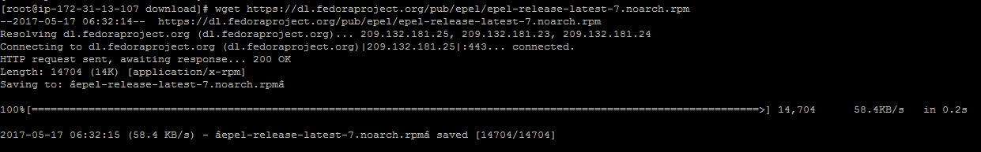

rpm -ivf epel-release-latest-7.noarch.rpm



yum install docker*

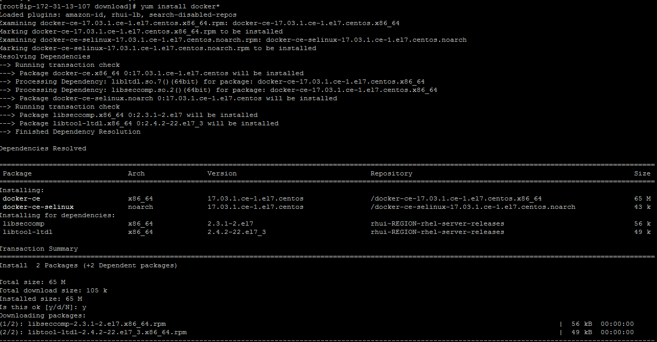

yum list installed | grep docker



systemctl start docker

systemctl status docker

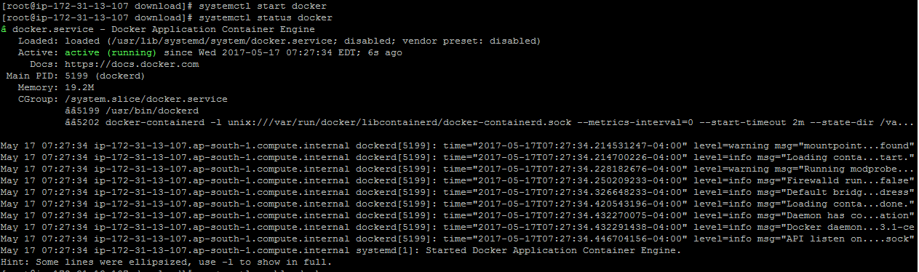

systemctl enable docker



docker run hello-world

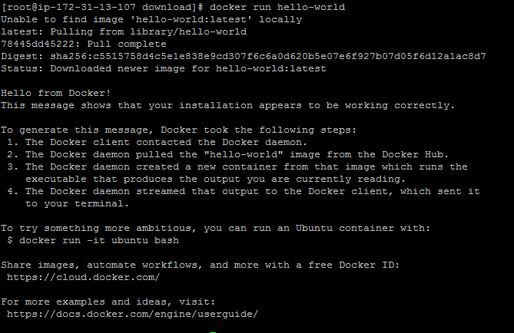

Download a Docker Image

In order to start and run a Docker container, first an image must be downloaded from Docker Hub on your host. Docker Hub offers a great deal of free images from its repositories.

To search for a Docker image, Ubuntu for instance, issue the following command:

# docker search centos

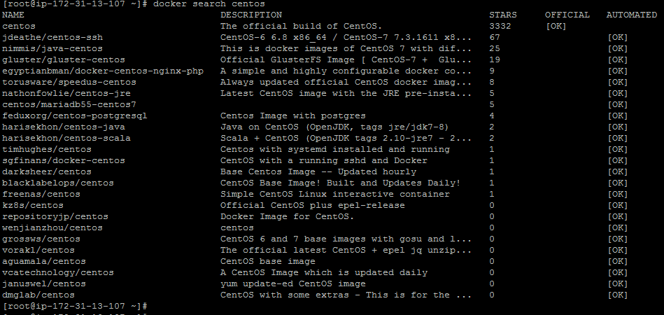

After you decided on what image you want to run based on your needs, download it locally by running the below command (in this case an Ubuntu image is downloaded and used):

# docker pull centos

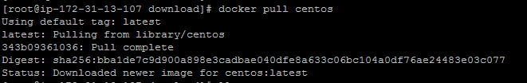

To list all the available Docker images on your host issue the following command:

# docker images

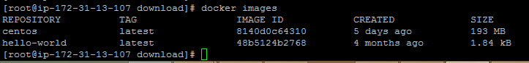

If you don’t need a Docker image anymore and you want to remove it from the host issue the following command:

# docker rmi centos

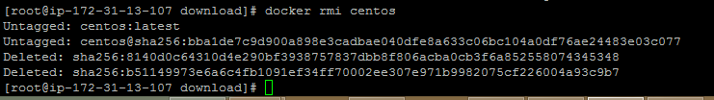

to create and run a container, you need to run a command into a downloaded image

# docker run [local image] [command to run into container]

to display the distribution version file inside the container

# docker run centos cat /etc/redhat-release

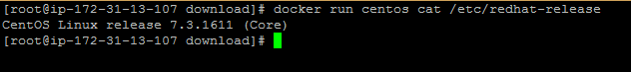

To run one of the containers again with the command that was executed to create it, first you must get the container ID (or the name automatically generated by Docker) by issuing the below command,

# docker ps -l



Once the container ID has been obtained, you can start the container again with the command that was used to create it, by issuing the following command:

# docker start 9299c2f95e82

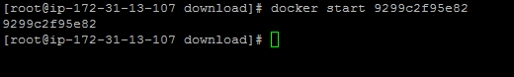

In case the container is running state, you can get it’s ID by issuing docker ps command. To stop the running container issue docker stop command by specifying the container ID or auto-generated name.

# docker stop 9299c2f95e82



the container ID would be to allocate a unique name for every container you create by using the --name option on command line

# docker run --name mydocker centos





n order to interactively connect into a container shell session, and run commands as you do on any other Linux session, issue the following command:

# docker run -it centos bash

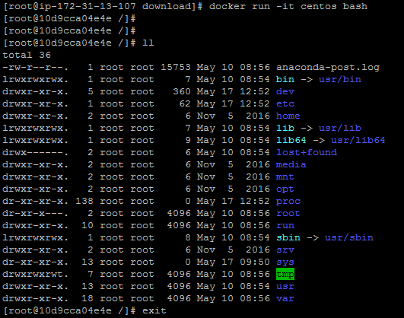

Type exit to quite session.